EXPLORATORY DATA ANALYSIS
INSIGHTS REPORT
Credit Risk Dataset - Patterns, Distributions & Behavioural Analysis
- Dataset: UCI Taiwan Credit Card Default
- Total Records: 30,000 credit card clients
- Target Variable: DEFAULT_NEXT_MONTH (Binary)
- Total Features: 24 predictor variables

Section 1: Target Variable Analysis - Default Behaviour
The target variable DEFAULT_NEXT_MONTH indicates whether a client defaulted on their payment in the following month.

1.1 Class Distribution
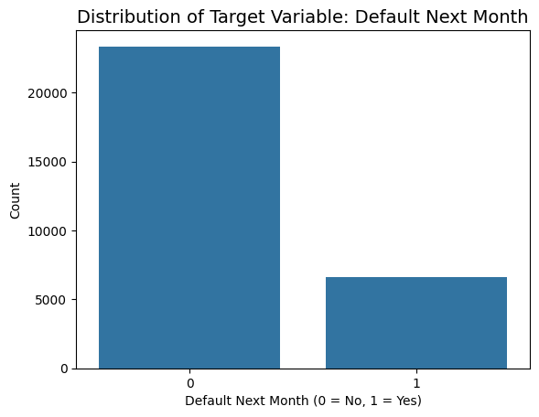
KEY INSIGHT | Approximately 77.88% of clients did not default, while approximately 22.12% defaulted in the following month. This constitutes a moderate class imbalance within the dataset.

Section 2: Customer Demographics
This section examines the demographic composition of the credit card portfolio across four variables: Age, Gender, Education, and Marital Status. These variables collectively describe the socioeconomic profile of the borrower base and allow for an assessment of whether demographic attributes are associated with differential default rates.

2.1 Overview of Demographic Distributions
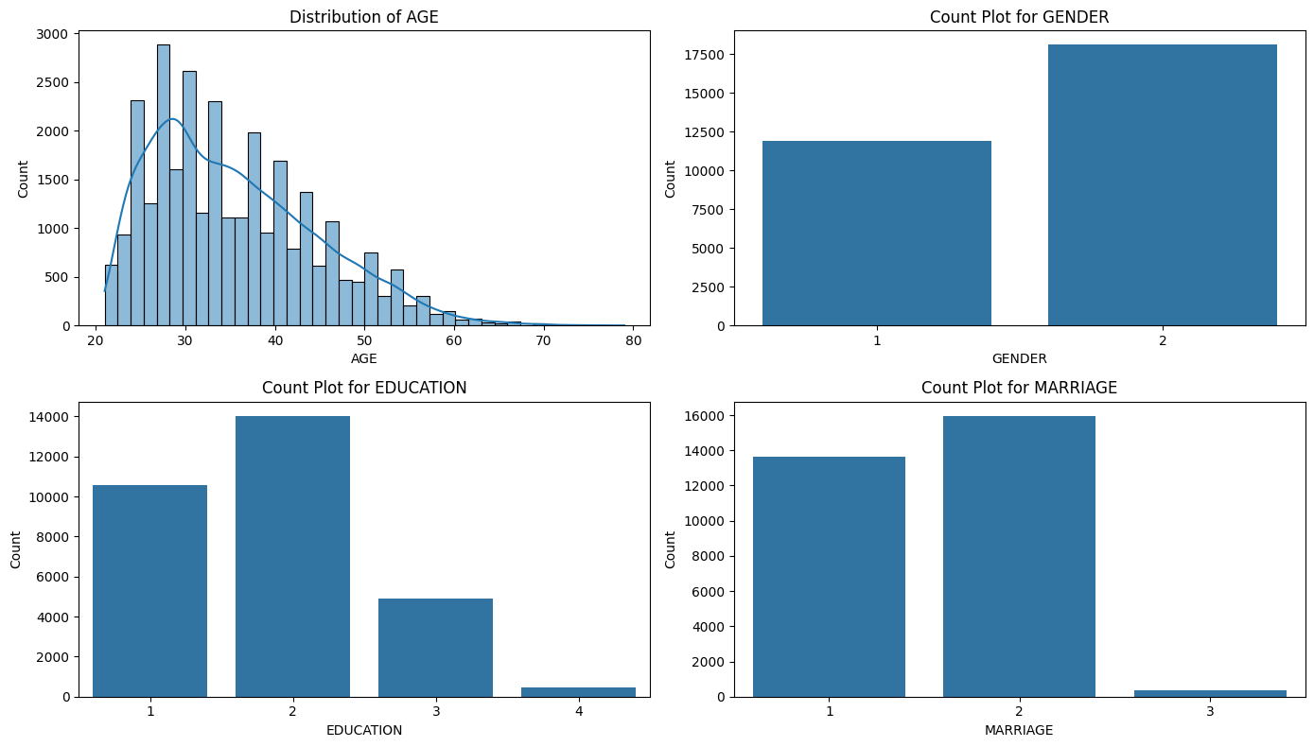
The above four plots provides a simultaneous view of the demographic composition across the full customer base. Each panel reveals a distinct distributional shape that characterises the borrower profile.

2.2 Age Distribution
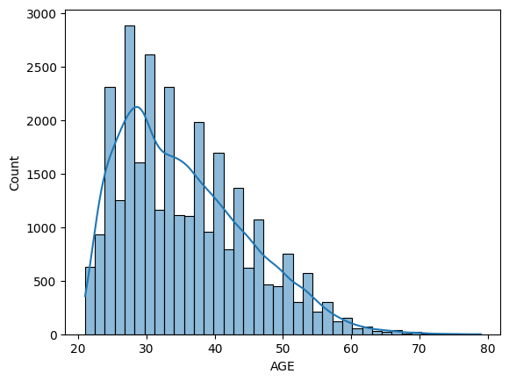
The age distribution is right-skewed, with the majority of clients concentrated between the ages of 25 and 45 years. The distribution peaks in the late 20s to mid-30s, representing a predominantly working-age adult clientele.

FINDING | The modal age group falls approximately between 27 and 32 years. Clients in this age band represent the single largest demographic segment in the portfolio, indicating that the bank's credit card product is predominantly consumed by young working professionals.

2.3 Gender Distribution
Gender is encoded as a binary variable with code 1 representing male clients and code 2 representing female clients. The count plot indicates that female clients constitute a slight majority of the portfolio, with the gender split being approximately 60% female to 40% male.

Gender | Approximate Count | Portfolio Share | Default Rate (Observed)
Male (Code 1) | ~11,888 | ~39.6% | ~24.2%
Female (Code 2) | ~18,112 | ~60.4% | ~20.8%

Male clients exhibit a marginally higher default rate than female clients, though the difference is small (approximately 3 - 4 percentage points). This differential, while observable, is not dramatic and suggests gender alone is a weak differentiator of default risk in this portfolio.

2.4 Education Distribution
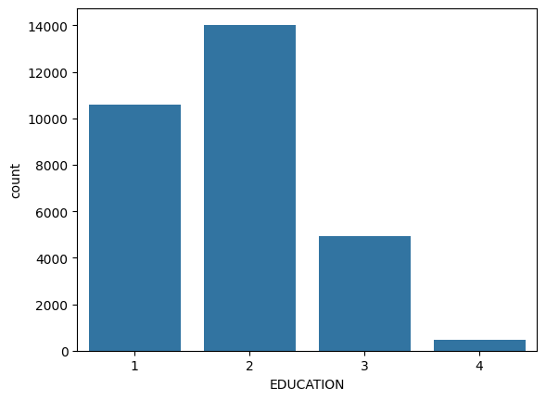
Education level is an ordinal categorical variable with four valid codes after data cleaning: 1 (Graduate School), 2 (University), 3 (High School), and 4 (Others). During the data preparation stage, undocumented codes 0, 5, and 6 were discovered in the raw dataset. These were remapped to the "Others" category (code 4) rather than removed, to avoid information loss and sampling bias.

NOTE | Undocumented education codes 0, 5, and 6 were present in the raw data. These were consolidated into the "Others" category (code 4). This decision was made to preserve the records while acknowledging their ambiguous educational classification.

Following remapping, the distribution shows that University-level education (code 2) forms the largest segment of the portfolio, followed by Graduate School (code 1). High School graduates (code 3) and Others (code 4) each represent smaller proportions.

FINDING | A clear gradient in default rates is observable across education levels: Graduate School clients exhibit the lowest default rates, followed by University clients. High School and Others categories show progressively elevated default rates. Higher educational attainment is associated with lower observed default frequency.
Education Level |  | Code | Relative Default Rate
Graduate School |  | 1 | Lowest
University |  | 2 | Low to Moderate
High School |  | 3 | Moderate to High
Others |  | 4 (incl. remapped codes) | Highest

2.5 Marital Status Distribution

Marital status is encoded with three valid codes: 1 (Married), 2 (Single), and 3 (Others). Similar to the education variable, an undocumented code 0 was present in the raw data. This was remapped to the "Others" category (code 3) following the same conservative approach applied to education.

The distribution is dominated by two categories: Married (code 1) and Single (code 2), which together account for the overwhelming majority of the portfolio. The "Others" category (code 3) represents a small residual segment.

FINDING | Single clients exhibit a marginally higher default rate than married clients. This observation is consistent with a financial stability hypothesis married households may benefit from dual income structures and greater financial resource pooling, moderately reducing default risk relative to single individuals.

The "Others" category, while small in size, should be interpreted cautiously given that it absorbs both the originally documented code 3 observations and the remapped code 0 observations.

Section 3: Credit Exposure & Limit Analysis
This section examines LIMIT_BAL, which represents the total amount of credit granted to each client in NT dollars (New Taiwan Dollars). LIMIT_BAL represents the total credit limit assigned to each client and reflects the bank’s exposure to that borrower. The analysis explores the distribution of credit limits, their segmentation into risk buckets, and the relationship between credit limit levels and default outcomes.

3.1 Distribution of Credit Limit (LIMIT_BAL)
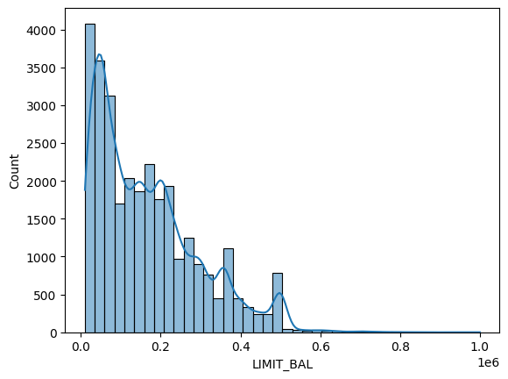
The credit limit distribution is strongly right-skewed, indicating that the vast majority of clients hold lower-to-moderate credit limits, while a small number of clients carry very high limits.

Statistic | Value (NT$) | Observation
Minimum | 10,000 | Floor credit limit in portfolio
Maximum | 800,000 | Highest exposure, likely premium clients
Distribution Shape | Strongly right-skewed | Most clients are low-to-mid limit holders

KEY INSIGHT | The right-skewed credit limit distribution reveals a portfolio dominated by clients in the lower and mid-range credit tiers. This is characteristic of a retail lending book serving a broad customer base that spans near-prime to subprime segments, with a concentrated minority of high-exposure accounts at the upper end.

3.2 Default Rate by Credit Limit Segment
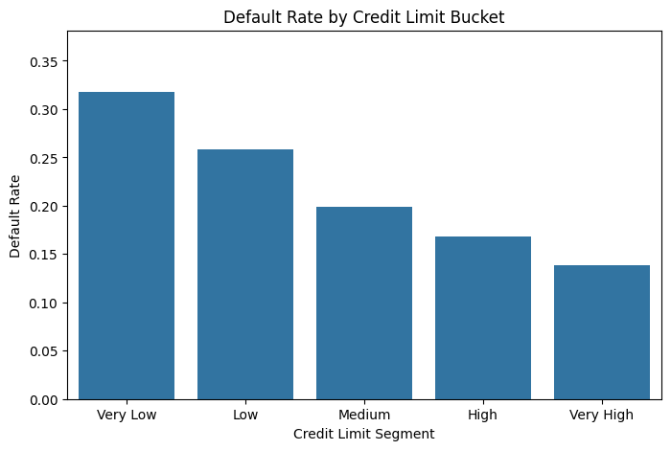
Credit limits were divided into five equal-frequency quintile-based buckets labelled Very Low, Low, Medium, High, and Very High. Default rates were computed for each segment to examine the association between credit limit level and default probability.
KEY INSIGHT | There is a clear and consistent inverse relationship between credit limit and default rate. Clients in the Very Low credit limit bucket default at the highest rate, while clients in the Very High bucket default at the lowest rate.

3.3 Credit Limit Distribution by Default Status
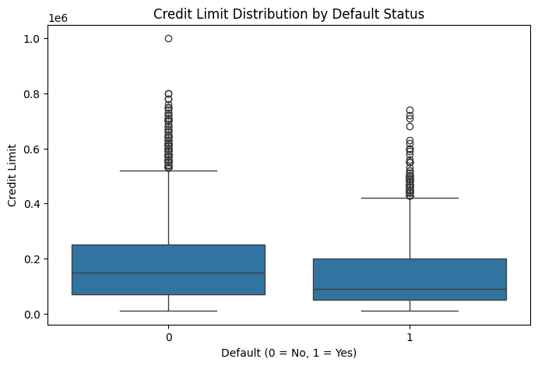
The box plot shows that non-defaulting clients have a higher median credit limit than defaulting clients. Both groups are right-skewed with some upper outliers, but the interquartile ranges clearly distinguish the two distributions, indicating higher credit limits are associated with lower default risk.
FINDING | Defaulting clients are mostly found in the lower credit limit range, with a lower median credit limit than non-defaulters. This distribution difference indicates that lower credit limits are associated with a higher likelihood of default.

Section 4: Repayment Behaviour Analysis
This section analyses the six repayment status variables PAY_0 through PAY_6 which record how late a client's payments were for each month from April (PAY_6) to September (PAY_0). The scale runs from negative values (indicating advance payment or no consumption) through 0 (payment in full) and up to 8 (months of delay). This dimension of the data captures the most direct behavioural signal about a client's credit discipline.

4.1 Distribution of Repayment Status Across Months
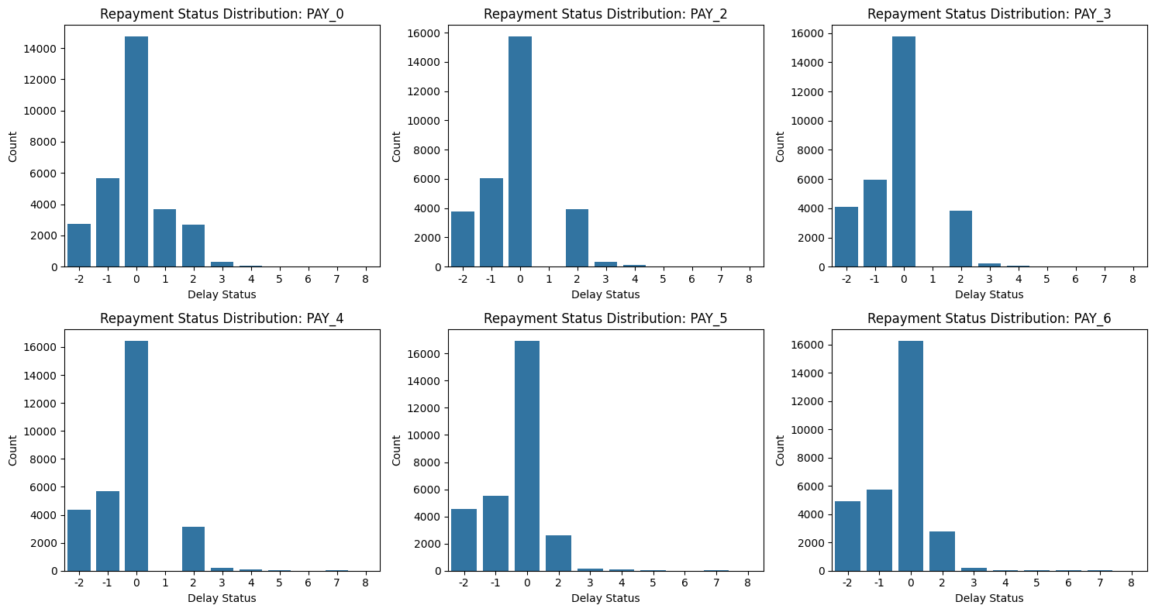
The six count plots reveal a consistent distributional pattern across all repayment status variables. In every month, the vast majority of clients are concentrated at values of −1, −2, or 0, indicating they were current on their payments or had advance credits. Positive delay values (1 through 8) represent a minority but are present in all six months.

FINDING | The repayment status distributions are heavily left-concentrated, with most clients clustered at 0 or below. However, a persistent tail of delayed payers is present across every observed month, indicating that a sub-population of the portfolio carries chronic payment difficulties throughout the entire observation window.

A notable feature of the distributions is that the proportion of clients with delays of 2 months or more (PAY ≥ 2) remains relatively stable across months, suggesting that delinquency in this portfolio is not a transient event but a persistent condition for those who experience it.

4.2 Default Rate by Repayment Delay Severity
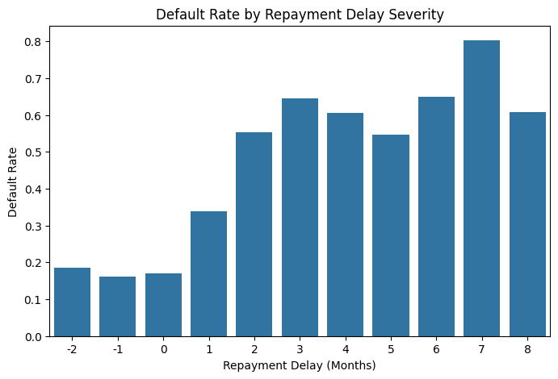
The relationship between delay severity and default rate was examined by pooling all six repayment status variables into a single analysis. Default rates were calculated for each distinct delay value to reveal how the probability of default changes as delay severity increases.

KEY INSIGHT | The relationship between repayment delay severity and default rate is near-monotonic and highly pronounced. Clients with no delay (PAY = 0) or early payment (PAY ≤ 0) exhibit default rates in the range of approximately 10%. As delay severity increases stepwise from 1 through 8 months, default rates escalate sharply reaching 50%+ for delays of 3 months and potentially exceeding 70 - 80% at the maximum delay values.

Repayment delay severity is the strongest predictor of default in the dataset.

4.3 Maximum Delay Across Six Months vs. Default
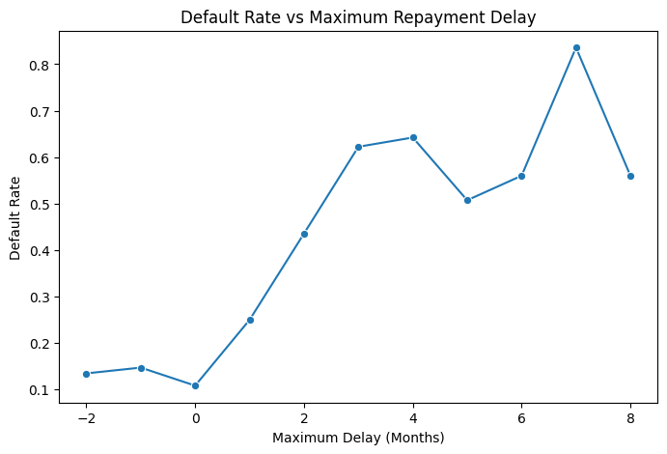
To capture the worst-case delinquency event for each client, the maximum delay value recorded across all six months was computed. The line chart plots default rate against this maximum delay value.

FINDING | The default rate rises sharply and consistently as the maximum delay increases. Even a single month at delay level 1 elevates the default rate substantially above the baseline. By delay level 3, the default rate is already above 50%, and the curve continues rising through the higher delay values. The near-linear escalation of this line confirms that worst-case payment behaviour is a reliable indicator of eventual default.

The line chart also reveals that very few clients with a maximum delay of 6 or more months escape default, as the curve approaches its ceiling at these extreme delay levels. This indicates that clients who ever reached severely delinquent status are highly unlikely to return to good standing within the observation window.

4.4 Frequency of Delinquencies
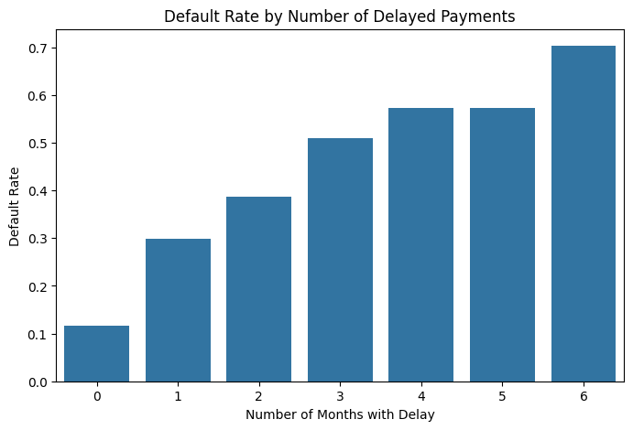
In addition to the severity of individual delays, the frequency of delayed months was examined. The number of calendar months within the six-month window during which a client recorded at least a one-month delay was counted for each individual.

KEY INSIGHT | Default rates increase monotonically with the number of months during which a client experienced a payment delay. Clients with zero delay months default at the baseline portfolio rate (~22%). Those with one delayed month show elevated rates. By four or more delayed months out of six, default rates exceed 60%. The relationship is nearly linear, confirming that delinquency frequency, not just severity is independently associated with default outcomes.

4.5 Clean vs. Delinquent Customer Segmentation
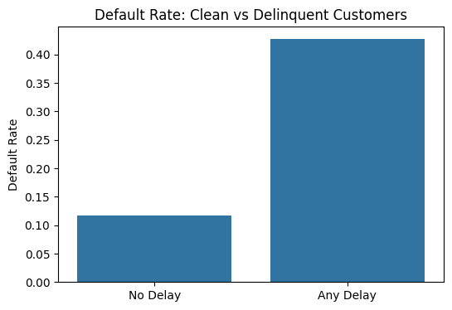
A binary segmentation was created to distinguish clients who experienced at least one payment delay in any month (ANY_DELAY_FLAG = 1) from those who maintained clean payment records throughout the six months (ANY_DELAY_FLAG = 0). This provides the simplest possible risk-based partition of the portfolio.

FINDING | The segmentation produces a striking contrast in default rates. Clients with no payment delays across all six months default at a rate of approximately 9 -11%, while clients who experienced at least one delay default at a rate of approximately 34 -38%. This represents a default rate approximately 3 - 4 times higher for the delinquent segment compared to the clean segment.

Section 5: Billing Amount Analysis
This section examines the six monthly bill statement variables — BILL_AMT1 (September 2005) through BILL_AMT6 (April 2005) — which record the outstanding balance on each client's credit card statement for each respective month. These variables represent the debt exposure dimension of the dataset and are analysed for their distributions, relationships with default, temporal trends, and internal correlation structure.

5.1 Distribution of Monthly Billing Amounts
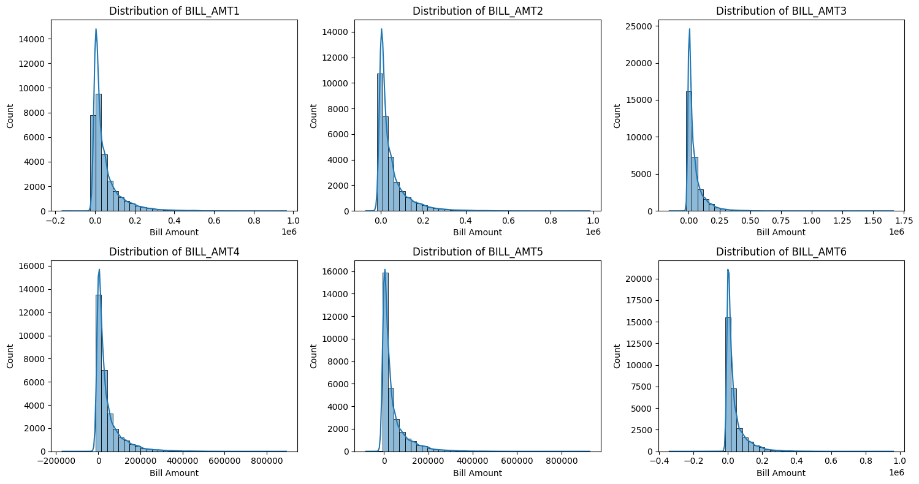
All six billing amount variables display a consistent distributional shape: extreme right-skewness with a large concentration of values near zero, a prominent body of moderate-value accounts, and a thin but extended upper tail reaching into the hundreds of thousands of NT dollars.

FINDING | Negative billing amounts are observed across all six months. These represent credit balances from client overpayments or refunds, and are legitimate data points reflecting responsible over-repayment behaviour. The presence of negative values confirms that the billing amount variable captures the full range of account states, from outstanding debt to net credit positions.

5.2 Billing Amount by Default Status
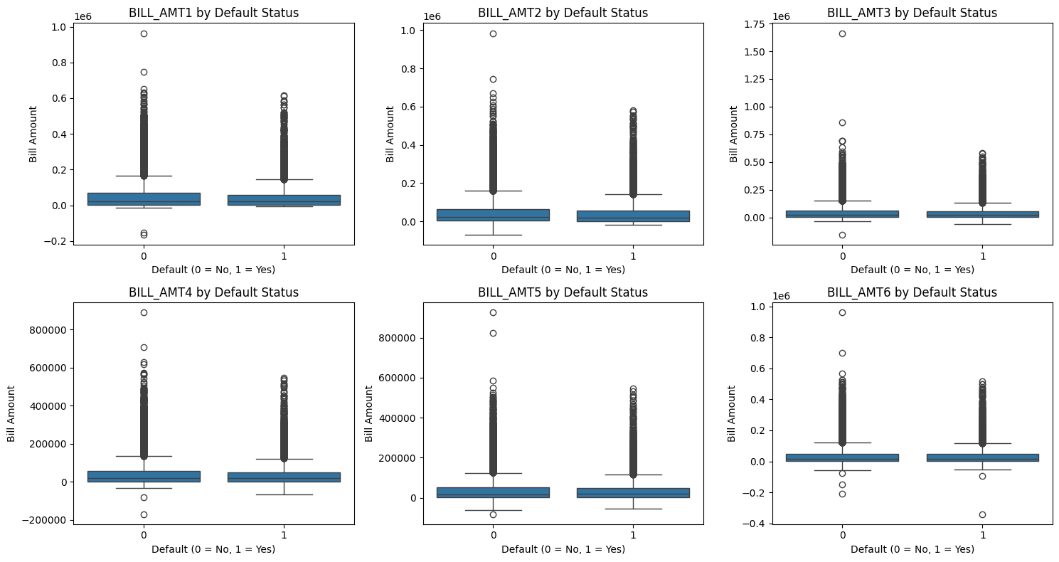
The box plots comparing billing amounts across default and non-default groups reveal a nuanced and somewhat counterintuitive pattern. In contrast to intuitive expectation, defaulting clients do not consistently show substantially higher billing amounts than non-defaulting clients. In fact, median billing amounts are relatively similar across both groups.

FINDING | The billing amount distributions for defaulters and non-defaulters substantially overlap across all six months. While non-defaulters show slightly higher median billing amounts in some months, the interquartile ranges overlap considerably. This indicates that billing amount alone is not a reliable discriminator of default status — the amount owed is less diagnostic than what proportion of it is being repaid.

5.3 Average Billing Amount Trend Over Time
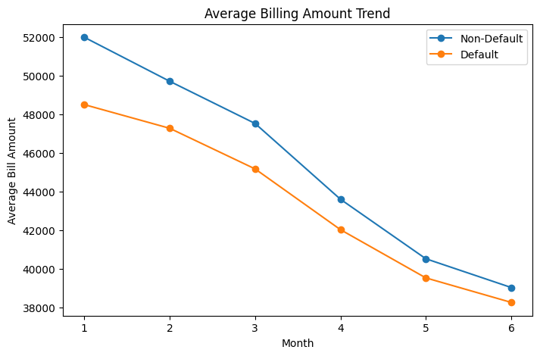
The average billing amount trend, plotted month by month from April through September 2005, separates default and non-default populations. The trend line is oriented from older to most recent months (right to left: September most recent).

KEY INSIGHT | A systematic pattern emerges in the temporal billing trend: defaulting clients maintain persistently higher average billing amounts across the entire six-month observation period compared to non-defaulting clients. Both groups show relatively stable average billing trajectories month-over-month, but the defaulting group's balances consistently sit at a higher level. This persistent elevated exposure indicates that clients who eventually default carried heavier ongoing debt burdens throughout the period.

5.4 Billing Growth Analysis (Debt Trajectory)
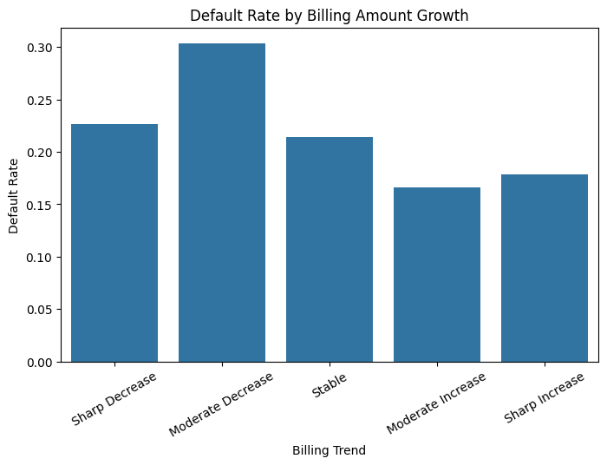
Billing growth was defined as the difference between the most recent month's bill amount (BILL_AMT1, September 2005) and the oldest month's bill amount (BILL_AMT6, April 2005). This measure captures the trajectory of a client's outstanding balance over the six months. Clients were bucketed into five quintile-based categories: Sharp Decrease, Moderate Decrease, Stable, Moderate Increase, and Sharp Increase.

FINDING | Clients with increasing bill amounts over six months show higher default rates, while those with stable or decreasing balances have lower default risk, especially when actively paying down debt.

5.5 Default Rate by Average Billing Level
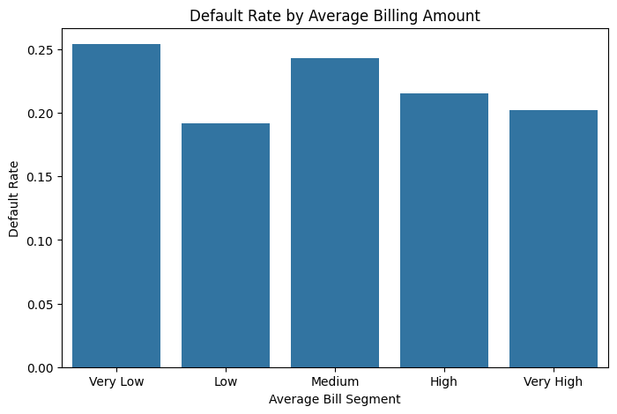
Average billing amount over the six months was computed and bucketed into five equal-frequency quintiles from Very Low to Very High. The default rate was computed per bucket.

5.6 Correlation Among Billing Amount Variables
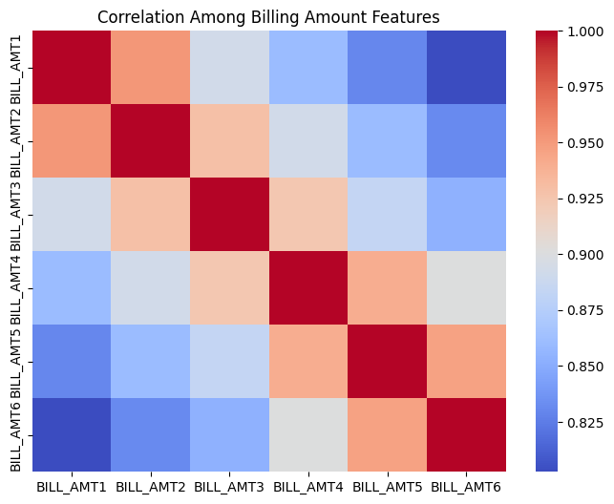

KEY INSIGHT | Adjacent monthly billing amounts exhibit extremely high positive correlations, with values exceeding r = 0.90 between consecutive months and reaching r = 0.93–0.95 between BILL_AMT1 and BILL_AMT2. Even non-adjacent months maintain correlations above r = 0.70–0.75. This reveals that the six billing amount variables are nearly redundant a client's billing level in one month is almost entirely predictable from their billing level in any other month within the observation window.

Section 6: Payment Amount Analysis
This section analyses the six monthly payment amount variables — PAY_AMT1 (September 2005) through PAY_AMT6 (April 2005) — which record the actual cash payments made by each client in the respective months. Unlike billing amounts, which reflect accumulated debt, payment amounts capture liquidity behaviour: the actual financial resources deployed by borrowers to service their obligations. This makes payment amounts a direct window into repayment capacity.

6.1 Distribution of Monthly Payment Amounts
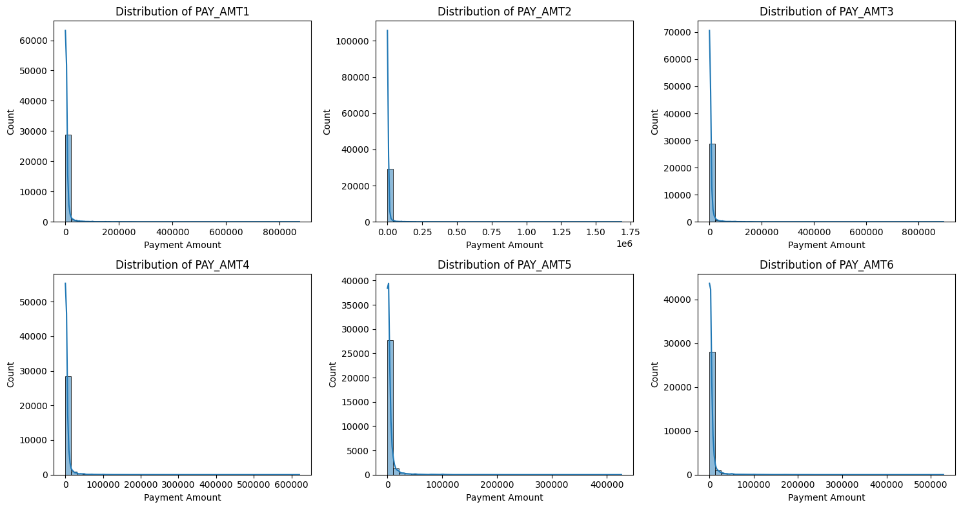
The six payment amount distributions share a common and extreme shape: an enormous mass at or near zero, representing clients who made little or no payment in a given month, followed by a sharp drop-off and a very long right tail representing large individual payments. The distributions are significantly more right-skewed than the billing amount distributions.

FINDING | A large number of clients show zero or minimal payments across all months, indicating a significant portion of the portfolio with very low repayment activity, which is a key risk indicator in the dataset.

The upper tails of the payment distributions extend to very high values, representing clients who make large lump-sum payments often equivalent to full balance clearance. These extreme payers exist at the opposite end of the risk spectrum from the zero-payment cluster.

6.2 Payment Amount by Default Status
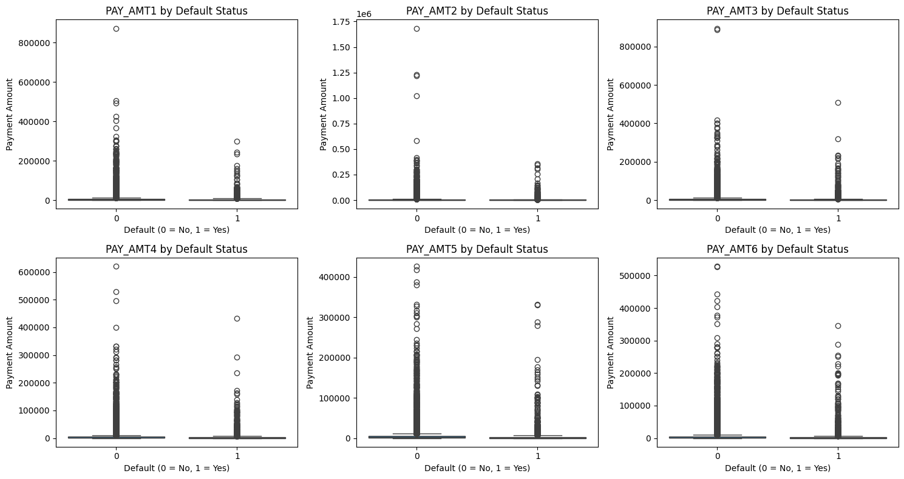
The box plots separating payment amounts by default and non-default status reveal a consistent and clear pattern across all six months.

KEY INSIGHT | Non-defaulting clients make higher payments in every month compared to defaulters. Defaulters are concentrated in the lower payment range with medians near zero, while non-defaulters show higher medians and a wider payment distribution.

6.3 Average Payment Trend Over Time
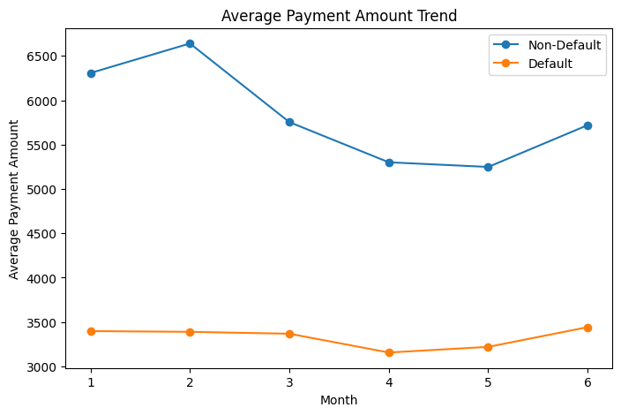
The average payment trend across six months, plotted for default and non-default groups separately, provides one of the most revealing temporal behavioural patterns in the dataset.

KEY INSIGHT | Non-defaulters consistently make higher average payments than defaulters across all months. Defaulters show persistently low or declining payments, indicating behavioral deterioration, while non-defaulters maintain relatively stable payment levels.

6.4 Zero-Payment Frequency Analysis
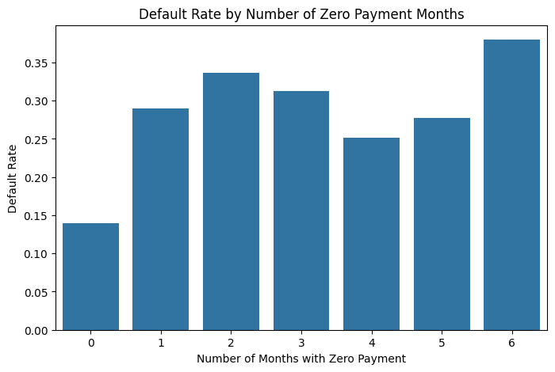
For each client, the number of calendar months in which they made a zero payment (PAY_AMT = 0) was counted, producing a variable ranging from 0 (no zero-payment months) to 6 (zero payment in all six months).

KEY INSIGHT | The relationship between zero-payment frequency and default rate is one of the most consistently monotonic patterns in the entire dataset. Clients with zero instances of non-payment default at the baseline rate (~15–18%). As zero-payment months accumulate, default rates escalate sharply and near-linearly. Clients who made zero payments in four or more months exhibit default rates exceeding 50–60%, and those with five or six zero-payment months approach default rates of 70–80%.

This pattern establishes zero-payment frequency as an extremely powerful behavioural indicator. It captures not just whether a client pays, but how consistently they fail to pay, a dimension of chronic non-repayment that is directly observable in this dataset.

6.5 Payment Stability Analysis
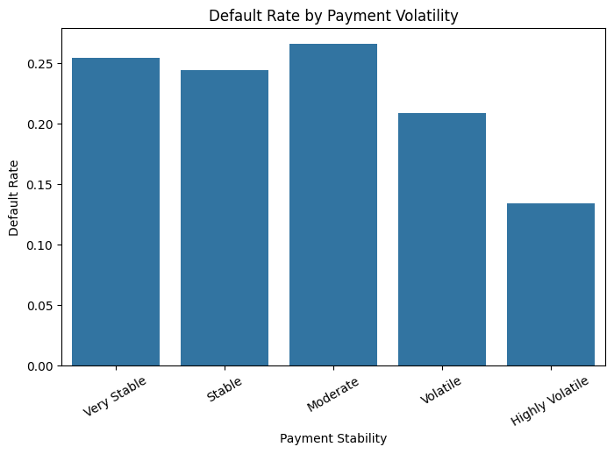
Payment consistency was examined through the standard deviation of each client's payment amounts across the six months, bucketed into five quintile groups from Very Stable to Highly Volatile.

FINDING | An interesting non-linear pattern emerges. Clients classified as Very Stable meaning their payments vary very little month to month show relatively elevated default rates. Examination of the data reveals this is because many of these "stable" payers are stable at near-zero payment levels. True low-risk payers tend to appear in moderate volatility categories, reflecting periodic larger payments interspersed with smaller ones. Highly volatile payers show mixed default rates depending on whether the volatility is driven by occasional large repayments or by irregular near-zero payments.

This finding illustrates that payment stability in isolation requires careful interpretation: stability at a low level is a risk signal, while variability driven by occasional large catch-up payments is not necessarily alarming.

6.6 Correlation Among Payment Amount Variables
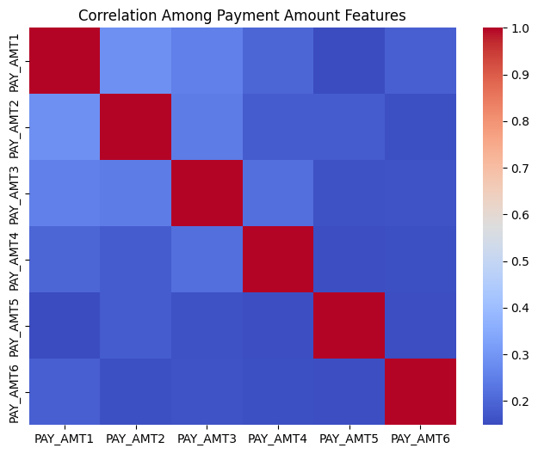
The correlation heatmap of the six payment amount variables reveals a markedly different structure from the billing amount variables.

FINDING | Payment amount correlations are moderate rather than extreme, typically ranging from approximately r = 0.40 to r = 0.65 between adjacent months and declining to r = 0.20–0.40 for more temporally distant months. This moderate correlation structure indicates that while a client who pays a relatively high amount in one month tends to pay more in adjacent months, the relationship is considerably weaker than for billing amounts. Payment behaviour shows more month-to-month variability, confirming that payment amounts capture more genuinely independent information across months than billing amounts do.

Section 7: Payment-to-Bill Ratio Analysis
This section analyses the Payment-to-Bill Ratio defined as the actual payment amount divided by the outstanding bill amount for each respective month. This derived measure normalizes payment behaviour relative to the bill amount, giving a clearer view of repayment capacity than raw values alone. When the bill amount was zero or negative, the ratio was set to zero to avoid division errors.

7.1 Distribution of Payment-to-Bill Ratios
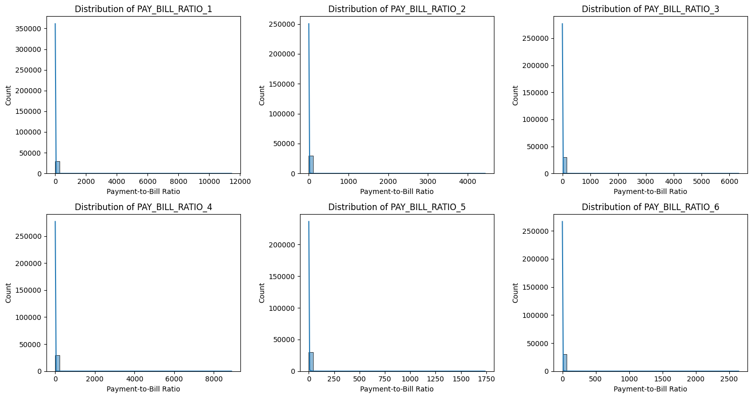
The Payment-to-Bill Ratio distributions across all six months reveal a trimodal structure: a large spike at exactly 0 (zero payment against a positive balance), a broad central body representing partial repayments (ratios between 0 and 1), and a spike or cluster at values above 1 (full or over-repayment of the outstanding balance).

FINDING | A strong zero-ratio spike appears across all months, showing many clients make no payment despite having outstanding balances, indicating high default risk. Ratios above 1.0 reflect overpayments, which are associated with very low default risk.

The intermediate values (0 < ratio < 1) represent the largest and most heterogeneous segment of the distribution partial payers whose risk profile depends on how close to full repayment their payments fall.

7.2 Payment-to-Bill Ratio by Default Status
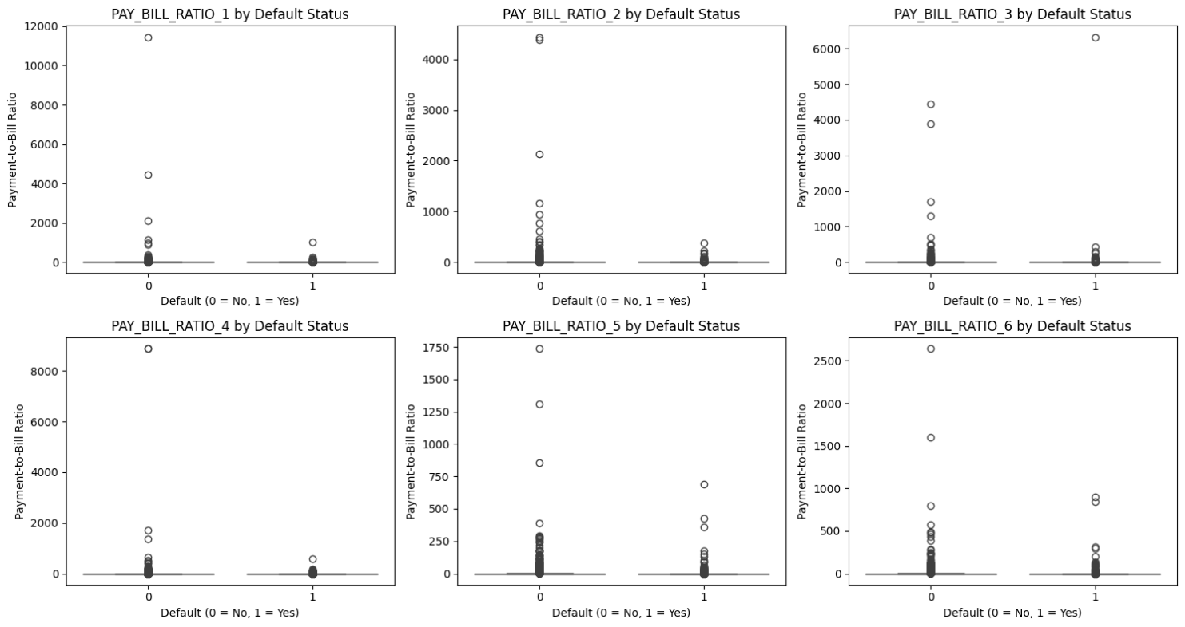

KEY INSIGHT | Defaulting clients have much lower Payment-to-Bill Ratios, often near zero, indicating minimal repayments. Non-defaulting clients show higher median ratios and wider ranges, making this ratio a strong discriminator between defaulting and non-defaulting groups.

7.3 Average Payment-to-Bill Ratio Trend Over Time
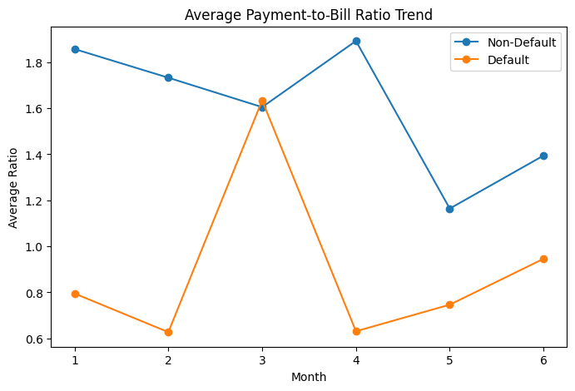
The temporal trend of average Payment-to-Bill Ratios, plotted month by month for default and non-default groups.
KEY INSIGHT | Non-defaulters maintain consistently high Payment-to-Bill Ratios, indicating regular repayment of balances. Defaulters show persistently near-zero ratios across all months, reflecting minimal repayments and a chronic repayment issue rather than a recent decline.

Section 8: Temporal Behaviour Analysis - Risk Over Time
This section synthesises the temporal dimension of the dataset by examining how repayment delays, billing amounts, and payment amounts evolve over the six-month observation window.

8.1 Month-wise Repayment Delay Trend
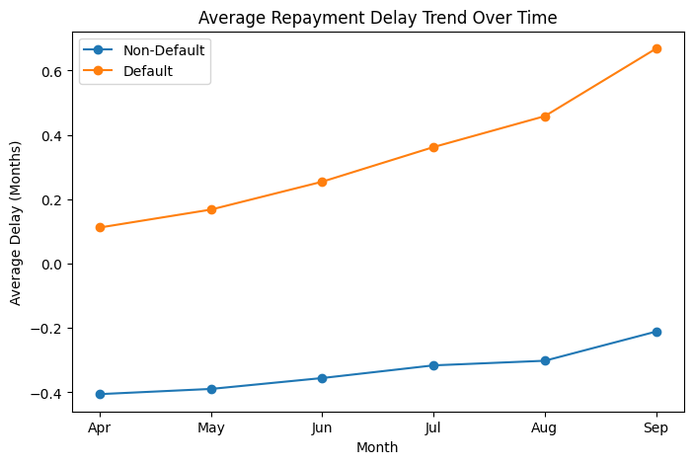
The month-wise repayment delay trend plots the average delay status for each month from April (PAY_6) through September (PAY_0), separately for defaulting and non-defaulting clients. The horizontal axis moves chronologically from left to right.

KEY INSIGHT | The two groups display fundamentally different delay trajectories. Non-defaulters maintain consistently low and stable average delay values throughout the entire six months, hovering near or below zero. Defaulters, by contrast, exhibit persistently elevated average delay values across all months, and crucially, the delay level increases as the observation window progresses towards September. This rising trend for defaulters represents a deterioration of payment behaviour in the months immediately preceding the default event.

The widening gap between the two trend lines as the months progress toward September is particularly significant. It confirms that the most recent repayment behaviour (captured in PAY_0 and PAY_2) carries the strongest differentiation between the groups, and that behavioural divergence accelerates as default approaches.

8.2 Month-wise Billing Amount Trend
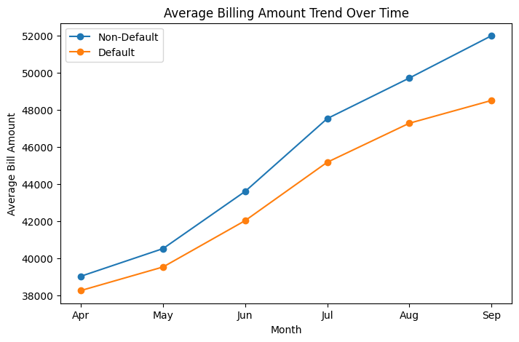
The billing amount trend plots average monthly bill amounts from April through September for default and non-default groups.

FINDING | Both defaulting and non-defaulting clients show relatively stable average billing amounts over the six months — there is no dramatic upward or downward trajectory for either group at the aggregate level. However, the defaulting group maintains a consistently higher average billing amount throughout the period. This persistent elevation of the defaulter's billing level confirms the observation from Section 5 that clients who eventually default carry heavier ongoing debt loads, though the absolute level of the bill is less diagnostic than the repayment behaviour.

8.3 Recent vs. Historical Behaviour Comparison
To explicitly quantify the recency effect, each client's most recent repayment status was compared against the average of their five earlier months.

Segment | Avg. RECENT_DELAY (PAY_0) | Avg. PAST_DELAY_AVG (PAY_2–6) | Interpretation
Non-Defaulters (0) | Low (near 0) | Low (near 0) | Consistently on time
Defaulters (1) | Elevated (> 1.0) | Elevated (> 0.5) | Chronic and worsening delays

KEY INSIGHT | Defaulters exhibit elevated delay values in both recent and historical periods, but the most recent period (PAY_0) shows higher average delays than the historical average. This confirms that default is not a sudden event, it is the culmination of an observable deteriorating trajectory. The recency of delinquency matters: the most recent repayment status is a stronger signal than historical averages, but both carry information about the final outcome.

Section 9: Correlation Analysis
This section examines the full pairwise correlation structure of the dataset's numerical variables, with dedicated analyses of the billing amount cluster, payment amount cluster, and the broader feature-to-feature interdependencies. Correlation analysis is critical for understanding the information overlap between variables and the structural integrity of the dataset.

9.1 Full Correlation Heatmap
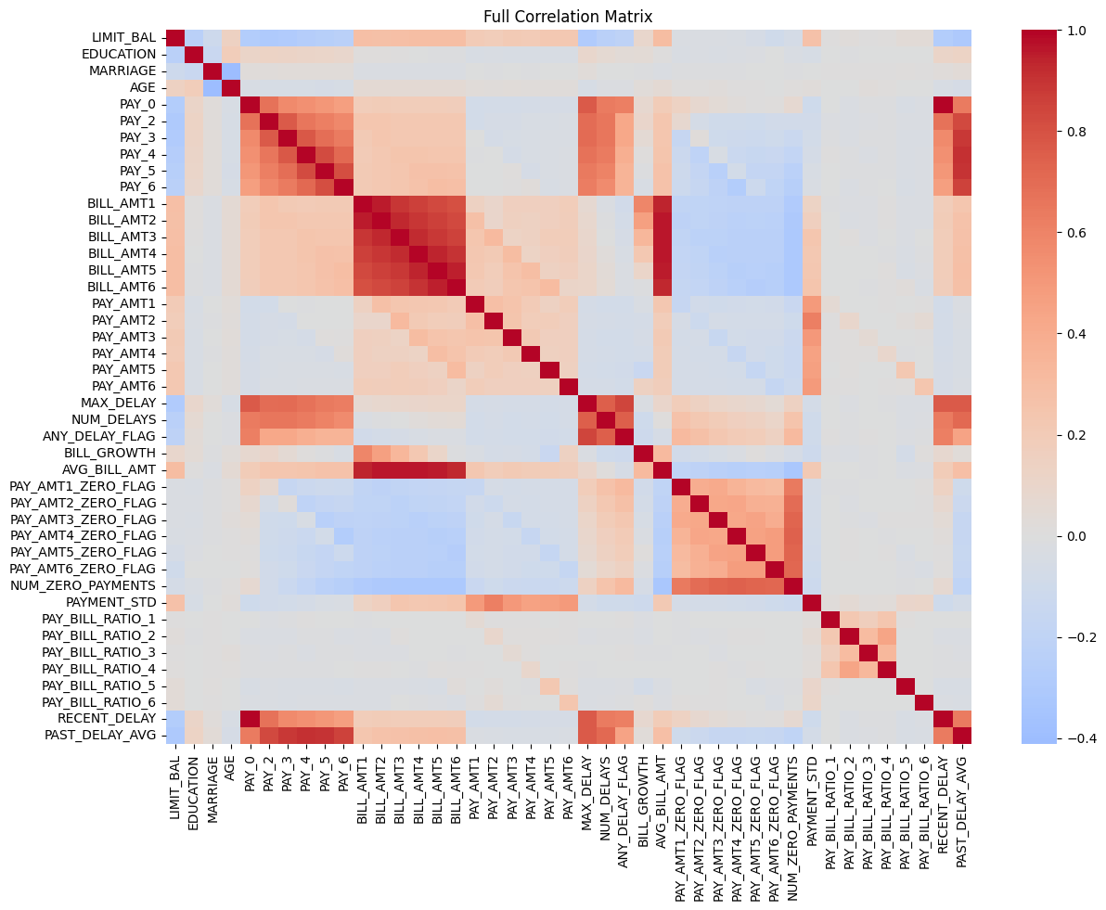
The heatmap shows three main correlation clusters:
- BILL_AMT variables – very highly correlated with each other.
- PAY status variables – moderately correlated and positively related to the default target.
- PAY_AMT variables – moderately correlated among themselves.
These clusters are largely independent, indicating that billing amounts, repayment behavior, and payment amounts represent different information dimensions in the dataset.

9.2 Correlation Among Billing Amount Variables
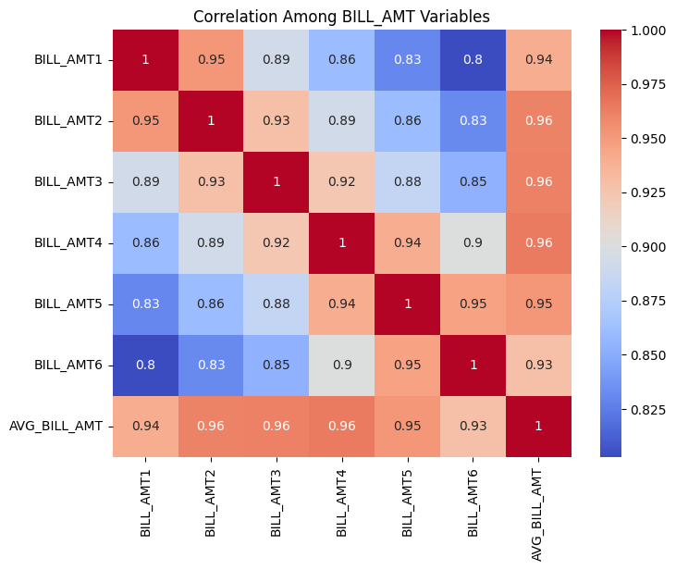
The dedicated billing amount correlation heatmap with numerical annotations provides exact correlation coefficients for the six billing variables.

Variable Pair | Correlation (r) | Relationship Strength
BILL_AMT1 & BILL_AMT2 | ~0.93–0.95 | Near-perfect positive correlation
BILL_AMT1 & BILL_AMT3 | ~0.89–0.92 | Extremely strong positive correlation
BILL_AMT1 & BILL_AMT6 | ~0.73–0.78 | Strong positive correlation
BILL_AMT3 & BILL_AMT4 | ~0.92–0.94 | Near-perfect positive correlation

This near-perfect correlation structure among billing amounts is a direct consequence of the revolving credit dynamics: a client's outstanding balance in any given month is primarily determined by the previous month's balance minus any payment made. Given the moderate-to-low Payment-to-Bill Ratios observed in this portfolio, balances persist month-over-month with minimal reduction, producing the observed extreme inter-month correlation.

9.3 Correlation Among Payment Amount Variables
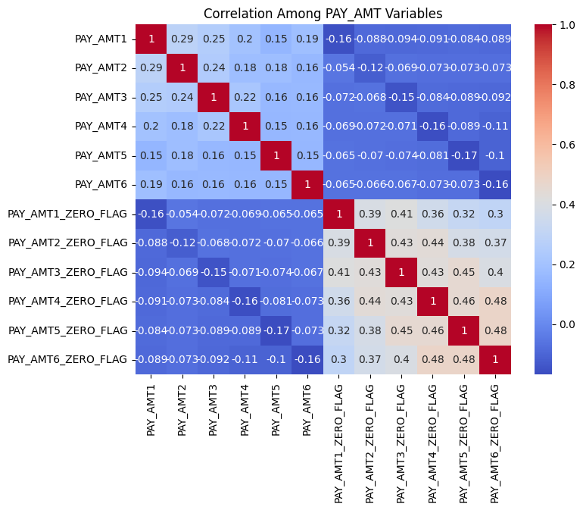
The payment amount correlation heatmap produces a notably different picture from the billing amount analysis.

FINDING | Payment amount correlations between adjacent months range from approximately r = 0.45 to r = 0.65, declining to r = 0.20–0.35 for temporally distant pairs (e.g., PAY_AMT1 vs. PAY_AMT6). While positive and meaningful, these correlations are substantially lower than those observed among billing amounts. This reflects the greater behavioural variability in payment activity: unlike balances which persist structurally, actual payment decisions represent active behavioural choices that vary more meaningfully from month to month.

The moderate correlation structure among payment amounts implies that while there is a general consistency in a client's payment capacity across months, the six payment amount variables are not redundant — each month's payment carries genuinely novel information about the client's financial behaviour at that point in time.

Section 10: EDA Summary

# | Dimension | Principal Finding
1 | Target Variable | 22.12% of clients defaulted, a moderate class imbalance reflecting a near-prime to subprime portfolio where one in five borrowers failed to meet their payment obligation in the subsequent month.
2 | Demographics | University graduates are the dominant education segment. Higher educational attainment is associated with lower default rates. Single clients default at marginally higher rates than married clients. Female clients are more prevalent but male clients show slightly higher default frequency. Age is concentrated in the 25-45 bracket with no strong monotonic age-default relationship.
3 | Credit Limit | LIMIT_BAL is right-skewed with the portfolio dominated by lower-limit accounts. A consistent inverse relationship exists: clients in the lowest credit limit quintile default at rates roughly 3× higher than those in the highest quintile.
4 | Repayment Behaviour | Repayment delay variables (PAY_0–PAY_6) exhibit the strongest and most consistent relationship with default of any variable group. Default rates are near-zero for on-time payers and escalate monotonically with delay severity, reaching 70–80% at maximum delays. The clean vs. delinquent segmentation produces a 3-4× default rate differential. Delinquency is chronic, not transient, for those who experience it.
5 | Billing Amounts | Billing amounts are right-skewed and extremely inter-correlated (r > 0.90 between adjacent months). Defaulters carry persistently higher average balances but the raw amount alone is a weak discriminator of default status. Growing bill balances are associated with higher default rates.
6 | Payment Amounts | Non-defaulters make substantially higher payments across all months. Zero-payment frequency is monotonically related to default probability, with clients recording 4–6 zero-payment months approaching 70-80% default rates. Payment amounts show moderate rather than extreme inter-month correlation (r = 0.40–0.65).
7 | Payment-to-Bill Ratio | The Payment-to-Bill Ratio produces the clearest visual separation between defaulters and non-defaulters of any variable in the dataset. Defaulters maintain persistently near-zero ratios throughout all six months a chronic failure to repay a meaningful fraction of their balance, while non-defaulters maintain consistently higher ratios.
8 | Temporal Behaviour | Behavioural divergence between defaulters and non-defaulters is a sustained multi-month pattern, not a sudden pre-default event. Repayment delay deterioration accelerates in the months immediately preceding default. The most recent repayment observations carry the strongest temporal signal.
9 | Correlation | Three internal correlation clusters exist (BILL_AMT, PAY, PAY_AMT). BILL_AMTs are severely collinear (r > 0.90). PAY_0 carries the highest individual positive correlation with the target. LIMIT_BAL carries the highest individual negative correlation with the target. Billing amounts individually show near-zero correlation with default.

